# Project Design Phase-ISolutionArchitecture

|  |  |
| --- | --- |
| Date | 01May2023 |
| TeamID | NM2023TMID19127 |
| ProjectName | Automated weather classification using transfer learning |
| MaximumMarks |  |

**SolutionArchitecture:**

Solution architecture is a complex process – with many sub-processes – that bridgesthegapbetweenbusinessproblemsandtechnologysolutions.Itsgoalsareto:

* Findthebesttechsolutiontosolveexistingbusinessproblems.
* Describe the structure, characteristics, behavior, and other aspects of thesoftwareto project stakeholders.
* Definefeatures,developmentphases,andsolutionrequirements.
* Providespecificationsaccordingtowhichthesolutionisdefined,managed,anddelivered.

# SolutionArchitectureDiagram:

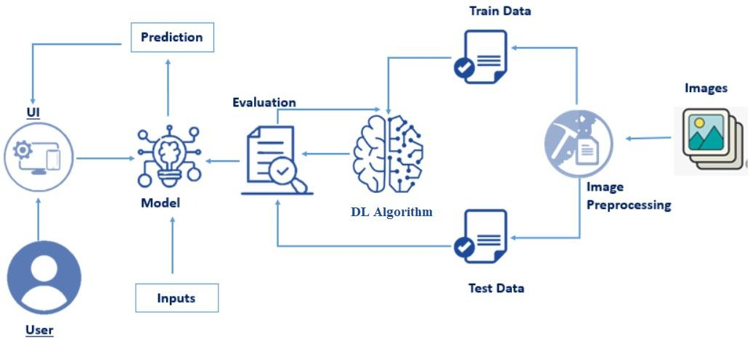

*Figure1:Architecture and data flow of automated weather classification using transfer learning*